**Day 3 Lab Assignments**

1. Make a Navbar like the following:

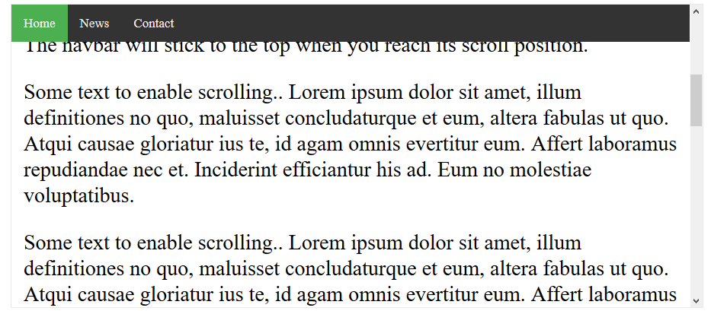

* 1. Make the navbar items as list (ul), and inside each list item (li), add a link for each menu item.
  2. Use list style type: none for the list items.
  3. Use display: inline-block for the list items. (Why?).
     1. What’s the difference between the following display values: inline, block, inline-block?

You can refer to the following links:

<https://www.w3schools.com/css/css_inline-block.asp>

<https://www.w3schools.com/cssref/pr_class_display.asp>

<https://stackoverflow.com/questions/9189810/css-display-inline-vs-inline-block>

<http://dustwell.com/div-span-inline-block.html>

<https://alligator.io/css/display-inline-vs-inline-block/>

<http://learnlayout.com/inline-block.html>

* 1. Handle that when mouse over an item its background color to be changed.

1. Made the previous navbar to be fixed position, and add any content below it (paragraph for example)
   1. You’ll need to push down the position all elements below the fixed elements, you may use padding property.
   2. Change the navbar to be position: sticky. (What’s the difference?).
2. Use z-index and position properties, to make a text above an image like the following:



1. Use flex property to make photo gallery like the following:

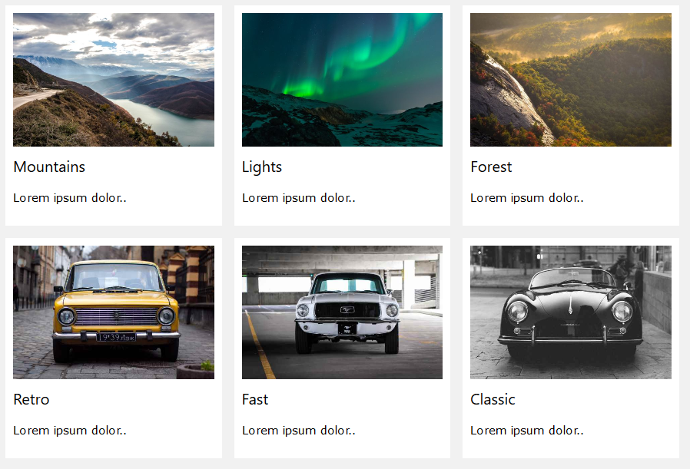

1. Use html ul tag and css features to make menu like the following:

(Use this menu as a drop-down menu in the bonus task)



**Bonus**



**<Script>document.write(“Thank YOU”) </Script>**